# 

# Table of content

1. **Introduction**

**1.1. Project Overview**

**1.2. Pre-trained model introduction**

1. **Methodology**

**2.1. Collecting and processing data**

**2.1.1. Data Collection Framework**

**2.1.2. Data Collection Framework**

**2.1.3. Implementation Process**

**2.2. Processing the data collection**

**2.2.1. Pre-processing data methodology**

**2.2.2. Implementation processing**

**2.2.3. After-processing data methodology**

**2.2.4. Implementation processing**

**2.3 Phobert model of emotion assessment**

**2.3.1. Model Architecture**

**2.3.2. Training Process (Fine-tuning)**

**2.3.3. Model Evaluation and Testing**

**2.3.3.1. Evaluation on the Test Set**

**2.3.3.2. Consistency Test**

**2.3.3.3. Edge Case Testing**

**2.3.3.4. Building a Demo Interface with Gradio**

**III. Conclusion and Future Work**

**3.1. Conclusion**

**3.2. Future Work**

1. **Reference**

## Introduction of topic

**1.1. Project Overview**

**Background and Context**

Natural Language Processing (NLP) represents a fundamental branch of artificial intelligence that focuses on enabling computers to understand and interpret human language, encompassing both written text and spoken communication. As technological advancement accelerates and human-computer interaction becomes increasingly prevalent across various domains, NLP has emerged as a critical and rapidly expanding field of study and application.

Sentiment analysis constitutes one of the most significant applications of artificial intelligence within the natural language processing domain. Unlike traditional text processing approaches that primarily focus on entity recognition and classification, sentiment analysis concentrates on understanding and evaluating human opinions, emotions, and attitudes toward specific subjects or topics. This capability provides valuable insights into public perception and consumer behavior patterns.

Product classification represents another essential component in practical applications of NLP technology. Rather than employing conventional methods that first categorize products and then retrieve descriptions based on predetermined categories, advanced applications can address classification challenges with greater specificity and accuracy. This approach significantly enhances the efficiency of product categorization processes and improves the quality of user review analysis.

**Current State of Technology**

Contemporary sentiment analysis algorithms have achieved remarkable accuracy rates through the implementation of next-generation technologies and sophisticated artificial intelligence frameworks. These systems employ advanced machine learning techniques to analyze textual content and identify emotional characteristics, determining whether sentiments expressed are positive, negative, or neutral in nature.

However, the majority of existing sentiment classification models have been developed primarily for English-language applications. While some Vietnamese language models exist, they typically focus on general commercial reviews rather than specific product categories. This limitation creates a significant gap in the availability of specialized tools for Vietnamese market analysis.

**Project Objectives**

This project addresses the identified gap by proposing a specialized model capable of classifying Vietnamese product reviews into two distinct categories: positive and negative sentiment. The primary objective is to develop a robust classification system that enables users to efficiently manage and evaluate customer feedback in the Vietnamese language context.

The proposed solution aims to provide businesses and organizations with enhanced capabilities for understanding customer satisfaction levels, identifying areas for improvement, and making data-driven decisions based on authentic user feedback. By focusing specifically on Vietnamese language processing, this project contributes to the development of localized NLP solutions that better serve regional market needs.

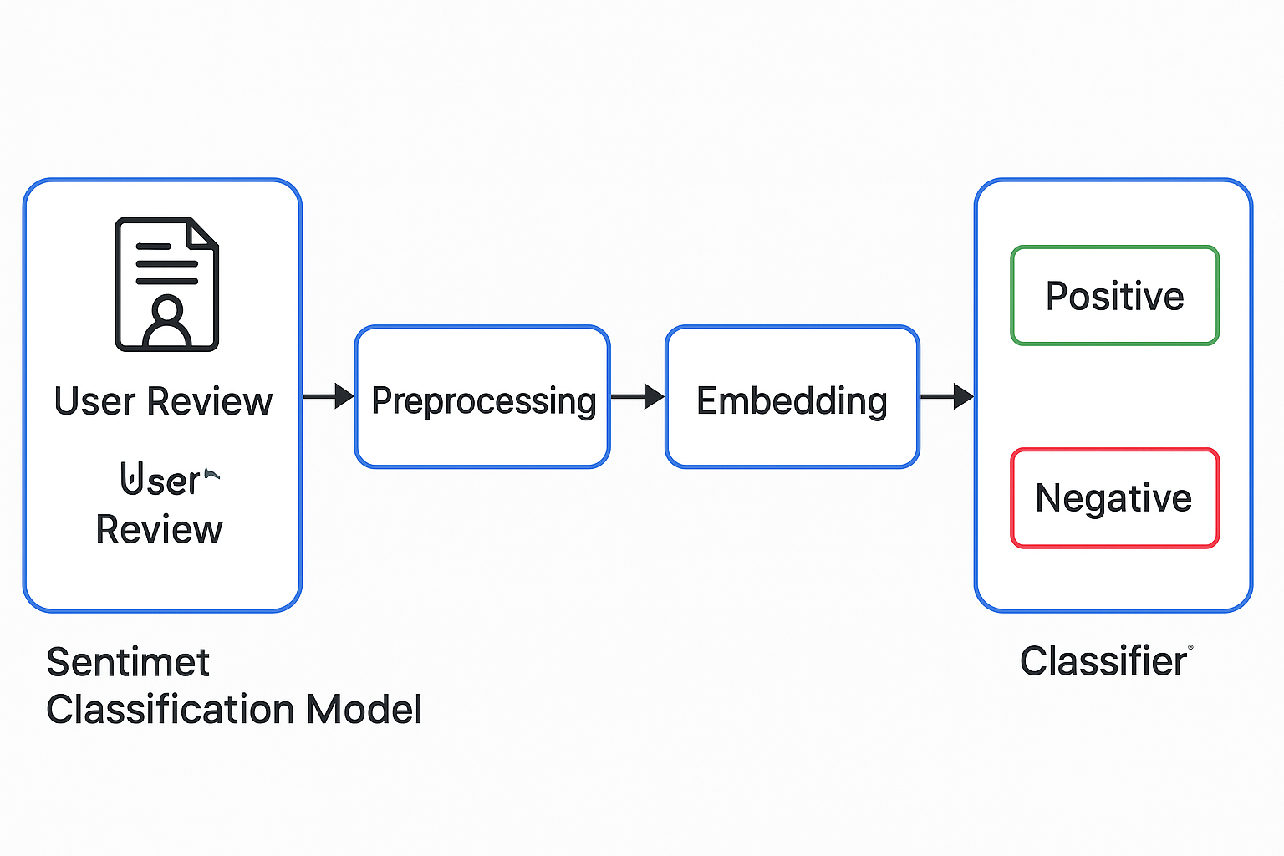

**Expected Impact**

The implementation of this Vietnamese sentiment analysis model will facilitate more effective customer feedback management, enabling organizations to respond appropriately to consumer concerns and preferences. This capability supports improved customer relationship management and contributes to enhanced product development strategies based on genuine market feedback analysis.

**1.2. Pre-trained model introduction**

Pre-trained models are deep learning models that have been trained on a large dataset before being applied to specific problems. In the field of natural language processing (NLP), models such as BERT, GPT, RoBERTa, and PhoBERT have been trained on millions of sentences of text from the Internet, helping them learn semantics, grammar, language structure, and word relationships in the text.

Unlike building and training a model from scratch, which requires time, computational costs, and large amounts of data, using a pre-trained model saves resources, shortens development time, and takes advantage of the general linguistic knowledge that the model has learned before.

|  | PhoBERT | viBERT | XLM-R (XLM-RoBERTa) |
| --- | --- | --- | --- |
| Training language | Vietnamese | Vietnamese | > 100 languages |
| Training data sets | 20GB | Large corpora of 10GB and 60GB  uncompressed Vietnamese text | 2.5TB multilingual data |
| Application | Sentiment analysis, classification, NER | Simple text classification | Multilingual tasks, machine translation |
| Hugging Face Integration | yes | yes | yes |

[1]

We chose PhoBERT in our project because it is a Vietnamese language model developed by the research team at VinAI Research, based on Google's famous BERT (Bidirectional Encoder Representations from Transformers) architecture.

PhoBERT operates on the principle of pre-training combined with fine-tuning, allowing the model to understand the contextual semantics of Vietnamese sentences better than traditional models. The base version of PhoBERT has 135 million parameters, equivalent to the BERT-base architecture, with 12 transformer layers and a hidden dimension of 768.

PhoBERT uses SentencePiece to encode the input sentence into subwords, helping to flexibly handle Vietnamese words that are not in the dictionary. This is one of the first models optimized for the Vietnamese language, and has been proven to achieve good results on many tasks such as text classification, sentiment analysis, NER, and question answering.

There are three types of popular pre-trained model from VinAI: [vinai/phobert-base-v2](https://huggingface.co/vinai/phobert-base-v2), [vinai/phobert-base](https://huggingface.co/vinai/phobert-base), [vinai/phobert-large](https://huggingface.co/vinai/phobert-large). [2]

| Model | #params | Arch. | Max length | Pre-training data |
| --- | --- | --- | --- | --- |
| [vinai/phobert-base-v2](https://huggingface.co/vinai/phobert-base-v2) | 135M | base | 256 | 20GB of Wikipedia and News texts + 120GB of texts from OSCAR-2301 |
| [vinai/phobert-base](https://huggingface.co/vinai/phobert-base) | 135M | base | 256 | 20GB of Wikipedia and News texts |
| [vinai/phobert-large](https://huggingface.co/vinai/phobert-large) | 370M | large | 256 | 20GB of Wikipedia and News texts |

1. Methodology

**2.1. Collecting and processing data**

**2.1.1. Data Collection Methodology**

The data collection process for this project involves comprehensive web scraping from Thegioididong, a prominent Vietnamese e-commerce platform. The methodology encompasses two distinct datasets: customer review comments and product descriptions, both essential for developing a robust sentiment analysis model.

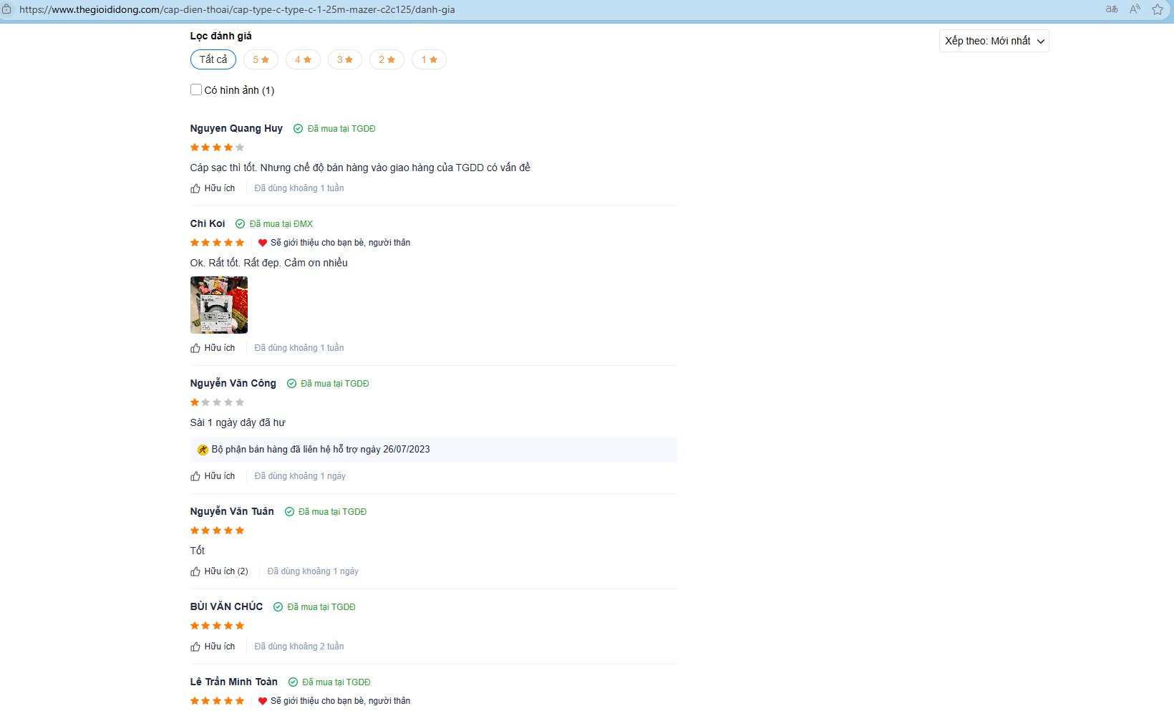

Figure: Comment to products which sold in TheGioiDiDong

**2.1.2. Data Collection Framework**

The data extraction process begins with an initial assessment of the target website's structure, starting from the base URL to establish a systematic crawling approach. This methodology ensures comprehensive data coverage while maintaining adaptability to potential website updates and structural changes.

**2.1.3. Implementation Process**

**Step 1:** We utilize Selenium to retrieve the entire page source and locate the div element with the class main-menu. This approach allows us to programmatically extract all product categories. Moreover, it ensures that if the website updates or adds new categories in the future, they will still be captured automatically.

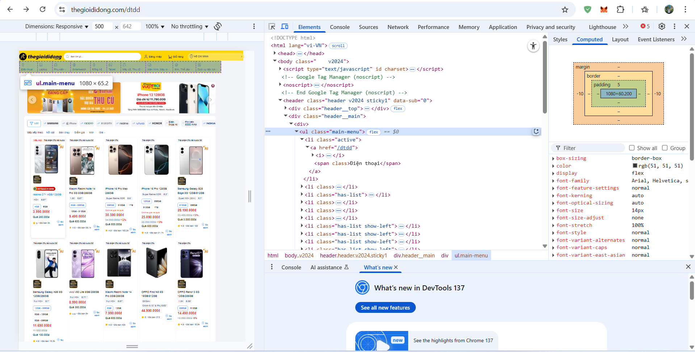

Figure. Web crawl data

**Step 2:**

Next, we programmatically visit each category page. To retrieve all the listed products, two conditions must be met:

(1) the category must contain available products, and

(2) the section should not be an advertisement block.

We simulate user actions to trigger the dynamic loading of products. After each trigger, we obtain the API query (as illustrated below). This triggering process continues until it is no longer possible, at which point we acquire the end_page_link representing the final page of products for that category.

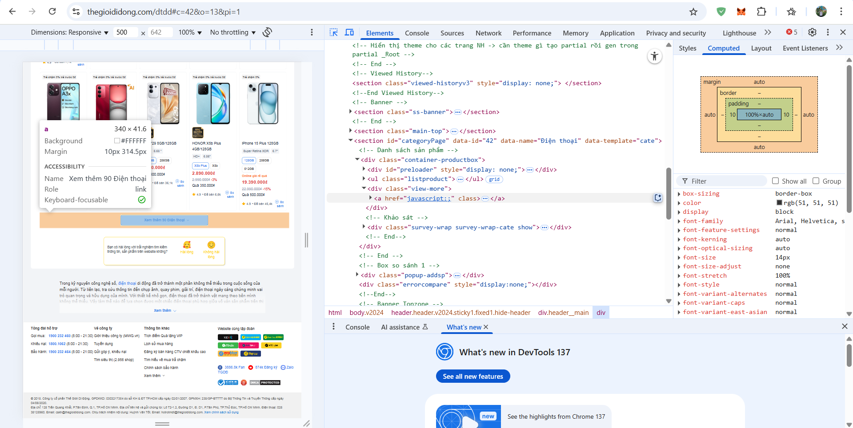  
Figure X. Illustration of the dynamic product loading mechanism via simulated user interaction.

**Step 3:**

All product data is saved into a CSV file, which serves as the input for subsequent crawling of product descriptions and user comments

Following a similar approach used to retrieve end_page_link, we simulate a click on the "View all reviews" button to access the full list of product reviews. We then increment the page number in the URL of the review section. If the resulting URL is valid and accessible, it will direct to the next page. Otherwise, an Exception will be raised, signaling the completion of comment crawling for the current product.

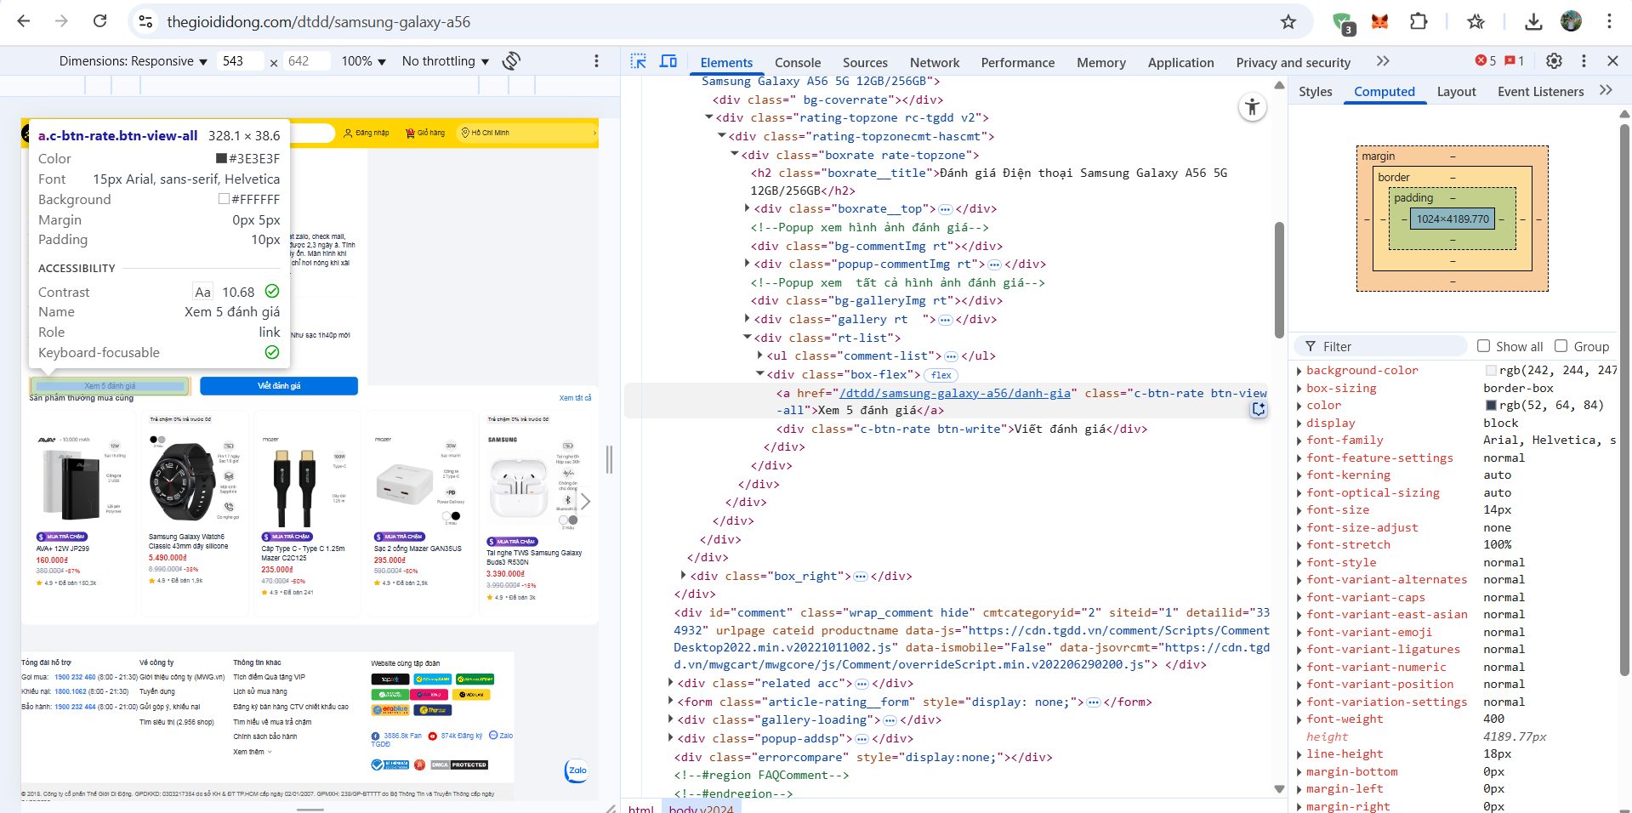

Figure . Visualization of the review-loading trigger process for a product.

To extract product descriptions, we first locate the div element with the class content-article. Within this container, we retrieve all p and span elements, as these typically contain descriptive text or product specifications. Since the content of these tags may vary significantly in both structure and purpose, we apply a filter based on text length. Specifically, we retain only those elements whose textual content exceeds 50 characters, thereby excluding irrelevant or overly concise entries.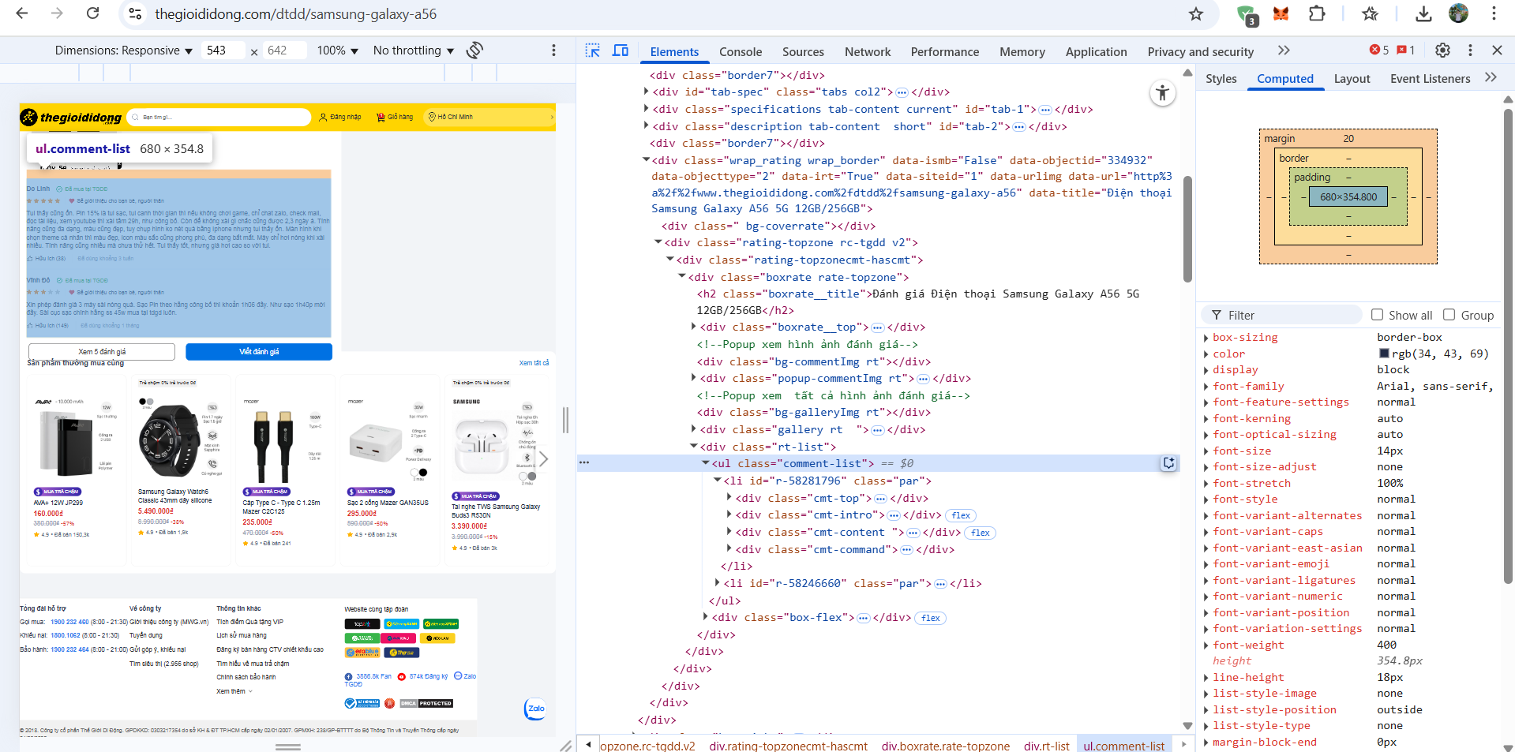

**Figure .** *Overview of the text data crawling process for product descriptions.*

**2.2. Processing the data collection**

**2.2.1. Pre-processing data methodology**

Data preprocessing is an essential step in any machine learning model building process, especially in natural language processing problems. Data collected from real environments such as websites often contain many noisy factors such as special characters, spelling mistakes, unnecessary words or inconsistent formats.

If not cleaned and normalized, these factors will reduce the training and prediction efficiency of the model. For the PhoBERT model - a pre-trained language model for Vietnamese - preparing the input in the correct format, including sentence normalization, punctuation removal and text tokenization, is a prerequisite for the model to work accurately. In addition, the process of assigning sentiment labels based on rating stars also plays an important role in turning raw data into a structured dataset, suitable for classification problems. Thus, preprocessing not only helps improve the accuracy of the model but also ensures the consistency, clarity and quality of the input data.

After collecting raw data from the website Thegioididong.com, the output data mainly includes user review sentences and corresponding star numbers. However, to ensure accuracy and efficiency in the process of training machine learning models, the data needs to be systematically preprocessed.

Preprocessing goals are to clean up text data, remove noise, Normalize input to match PhoBERT model's tokenizer, Assign sentiment labels to each rating based on star ratings.

**2.2.2. Implementation processing**

**Step 1: Lowercasing**

Objective: Convert all text to lowercase to eliminate case sensitivity in word comparison.

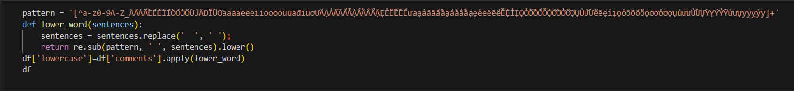

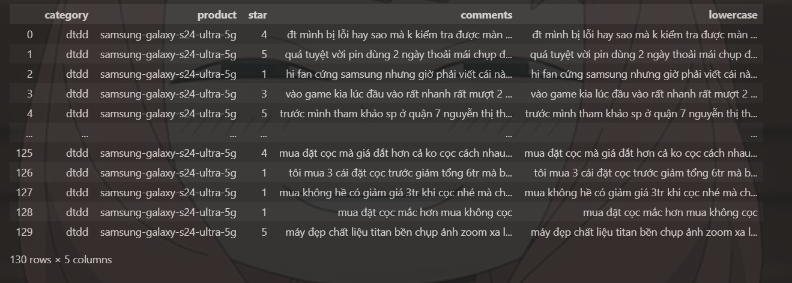

Before: "Sản phẩm Tốt quá!" →  
 After: "sản phẩm tốt quá"

Why: Words like "Tốt" and "tốt" should be treated as the same word to ensure consistency in feature representation.

**Step 2: Removing Punctuation and Special Characters**

Objective: Clean the text by removing punctuation marks, emojis, and other special characters.

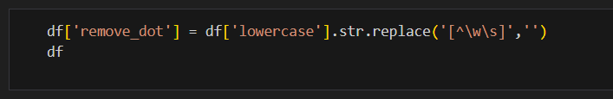

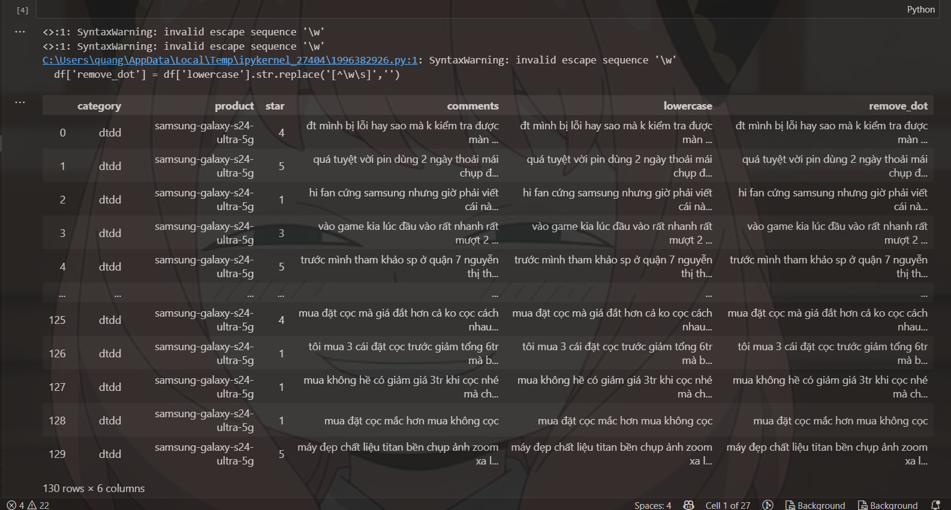

Before: "sản phẩm tốt quá!!! 😍" →

After: "sản phẩm tốt quá"

Why: These symbols typically do not carry useful information for sentiment classification.

**Step 3: Removing Numbers**

Objective: Eliminate numeric values from the text, as they generally do not convey sentiment.

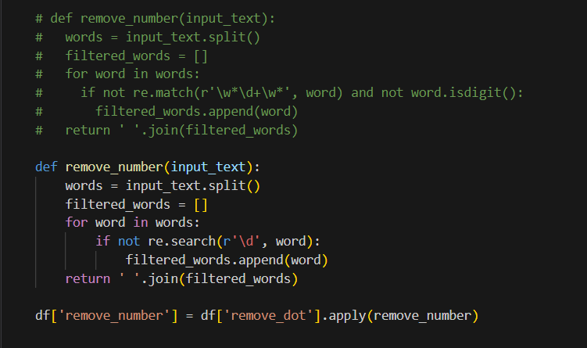

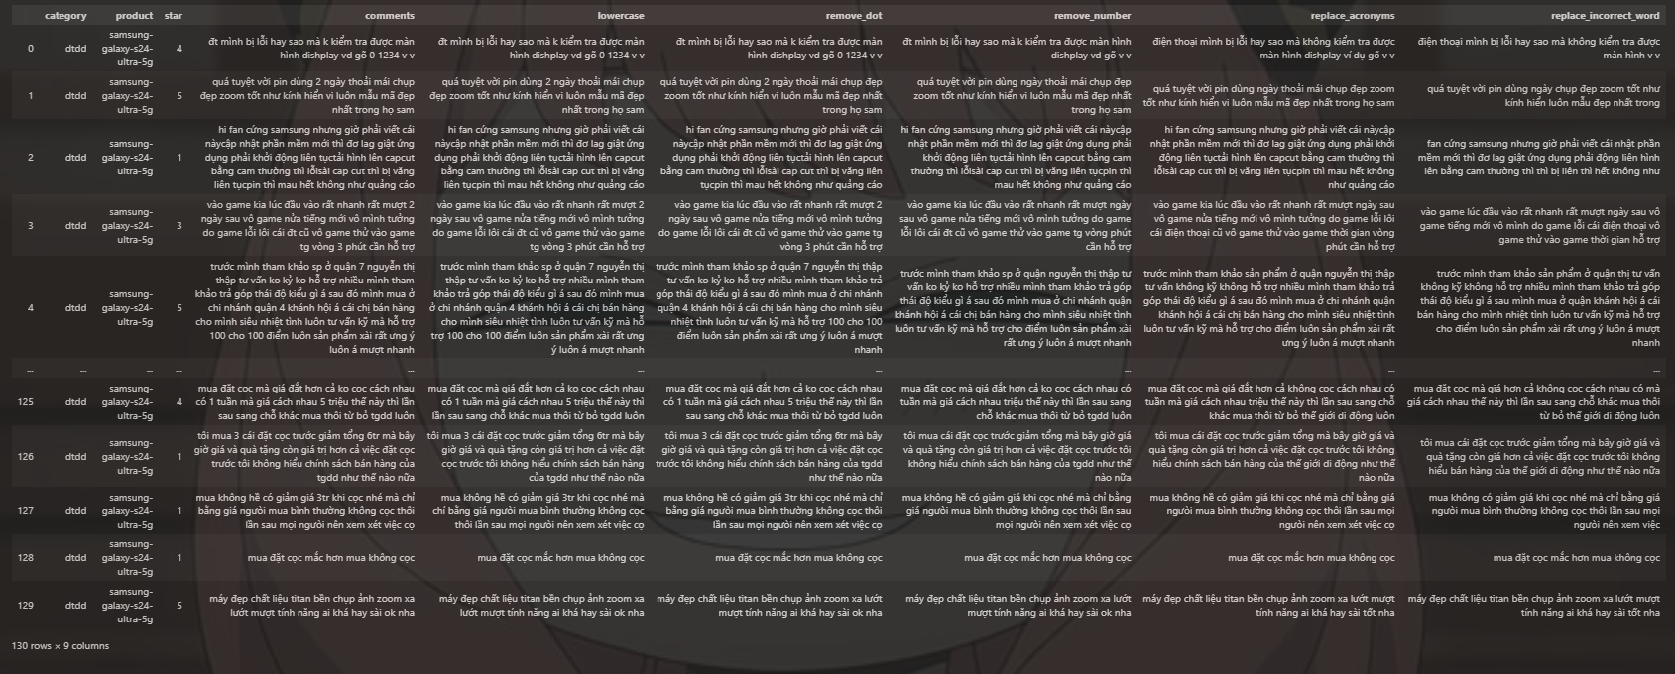

Before: "giao hàng trong 2 ngày" →  
After: "giao hàng trong ngày"

Why: Numbers may refer to quantity or time, which are often irrelevant in sentiment analysis.

**Step 4: Replacing Acronyms and Misspellings**

Objective: Normalize the vocabulary by replacing informal words or abbreviations with their standard equivalents using a predefined dictionary.

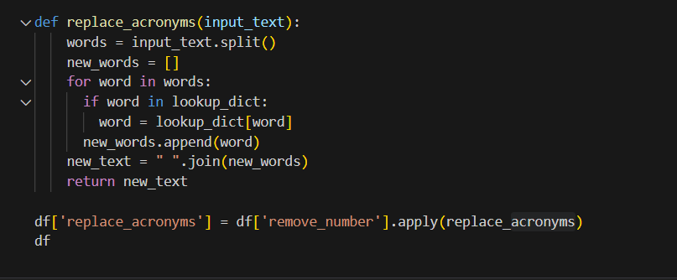

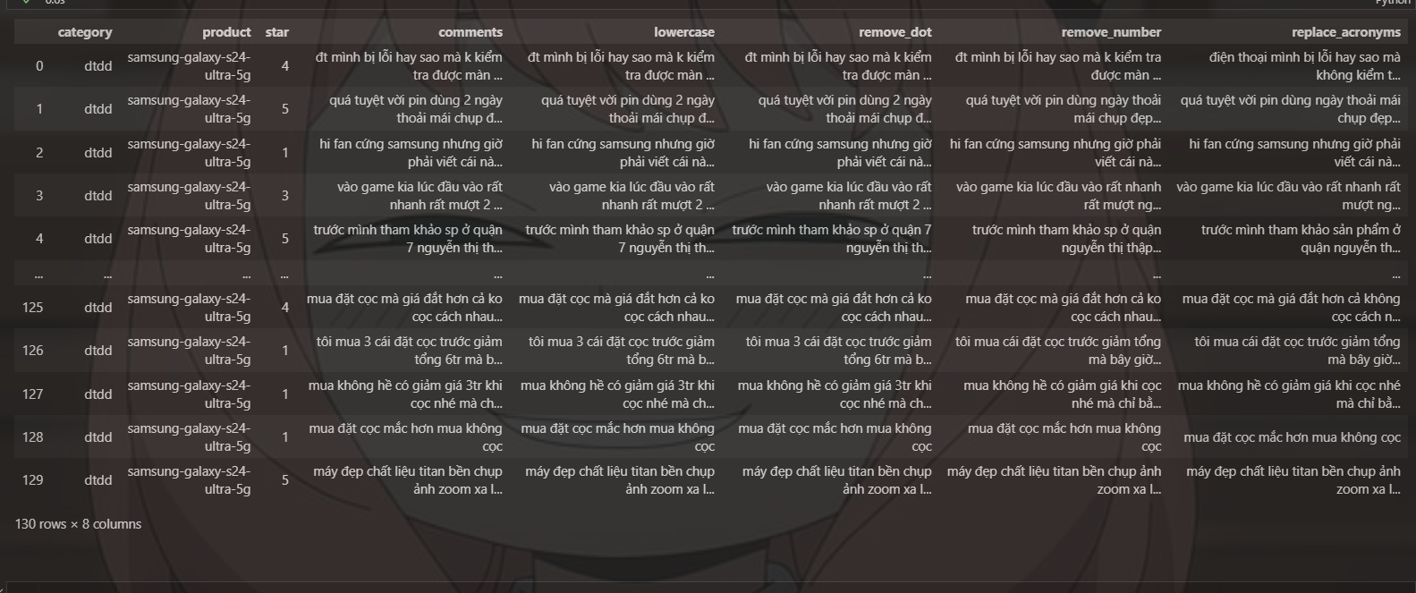

Before: "sp oke nha, ko xấu"  
 After: "sản phẩm ok nha, không xấu"

Why: This step improves data quality and helps the model understand the actual meaning of the comments.

**Step 5: Removing Duplicate Comments**

Objective: Remove repeated comments from the dataset to avoid bias in model training.

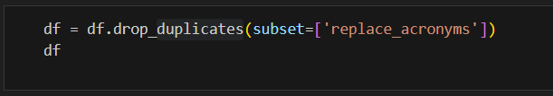

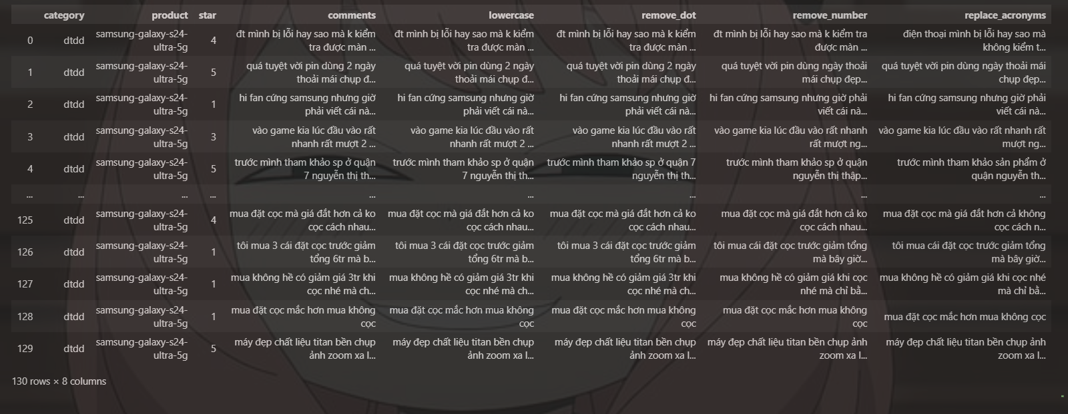

Why: Ensures model training is based on diverse and meaningful data points, preventing overfitting.

**Step 6: Removing Rare Words (Single-occurrence Words)**

Objective: Eliminate words that appear only once in the entire dataset as they are likely to be typos or noise

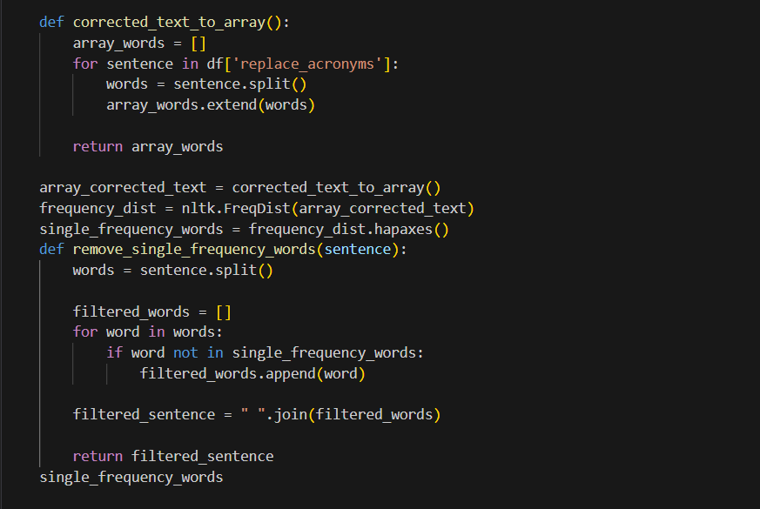

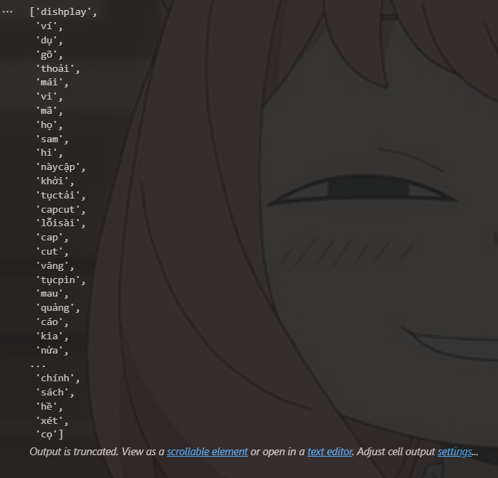

Why: These low-frequency words usually don’t contribute to learning useful sentiment patterns.

**Step 7: Exporting Word Frequency**

Objective: Create a frequency table of words for further analysis or visualization.

**Step 8: Removing Stopwords (Vietnamese and English)**

Objective: Eliminate common words (e.g., “is”, “and”, “là”, “của”) that do not contribute significant meaning to sentiment.

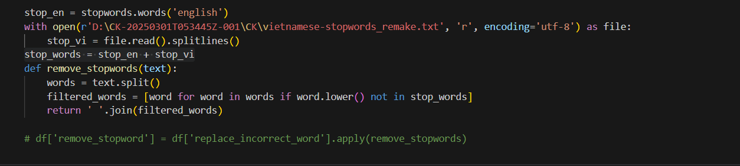



Before: "sản phẩm này là của tôi"  
 After: "sản phẩm"

Why: Stopwords are functional words that don’t usually reflect the opinion or emotion in a sentence. Removing them improves the clarity of the training features.

**Step 9: Spelling Correction using Pretrained Model**

Objective: Automatically correct spelling mistakes to enhance the consistency and quality of the dataset

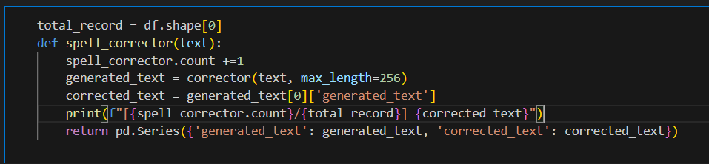

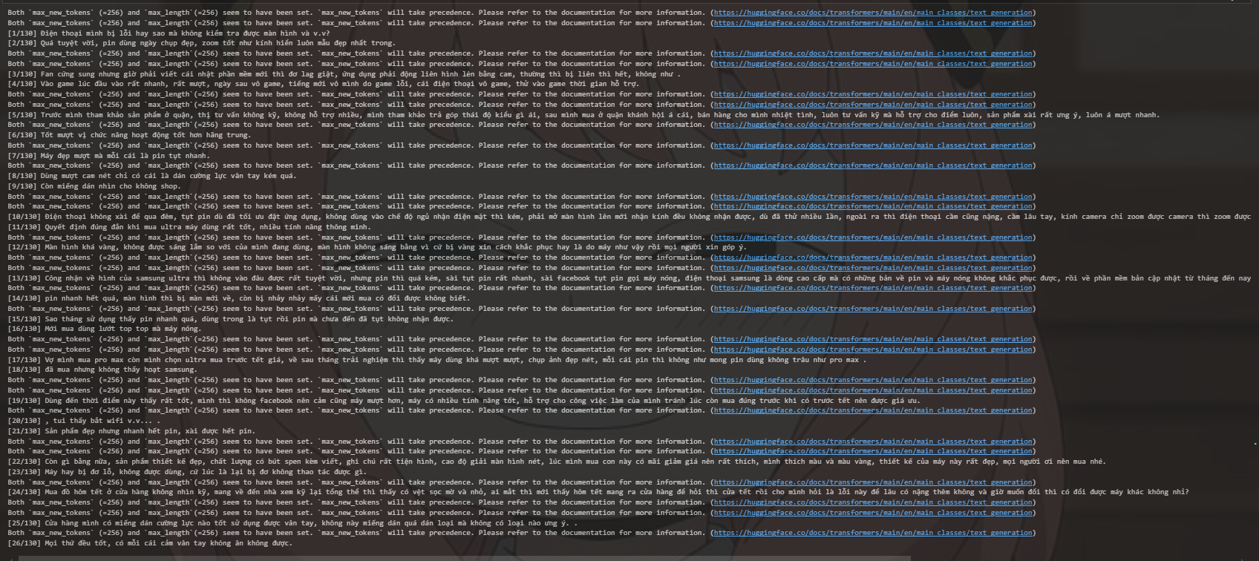

Why: Typos and incorrect grammar can confuse the model. Correcting them improves both training quality and performance.

**Summary**:

-Data cleaning removes irrelevant noise from text.

-Standardization helps the model recognize similar patterns.

-Efficiency and accuracy in model training improve due to reduced vocabulary and noise.

**2.2.3. After-processing data methodology**

After completing the text preprocessing step to clean and standardize the language, the output data is still in plain text and cannot be directly used for deep learning models like PhoBERT. Therefore, a post-processing step is needed to convert the data from natural language to a digital format that meets the model's input requirements.

Specifically, in the post-processing step, the text sentences will be tokenized using PhoBERT's tokenizer - AutoTokenizer.from_pretrained('vinai/phobert-base'). This tokenizer will convert each sentence into a string of ID tokens , along with an attention mask to mark the actual content and the padded part. In addition, strings that are too long will be truncated to the maximum length, while shorter strings will be padded to synchronize the input size.

The result of this step is a tensor-like dataset (including input_ids, attention_mask, labels) that can be directly used to train the PhoBERT model with PyTorch. Thus, post-processing acts as a bridge between the processed language data and the deep learning model, ensuring that the input data has a consistent structure, format, and length.[3]

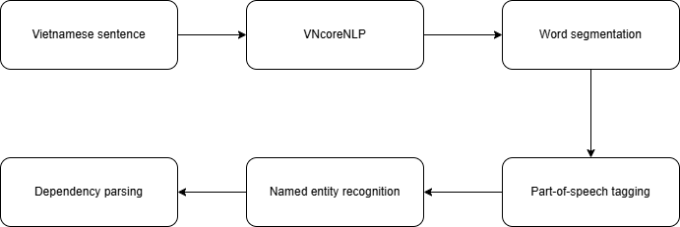

**2.2.4. Implementation processing**

**Step 1**: Read the data_combine.csv file from the Google Drive folder, remove the first column that is not needed.

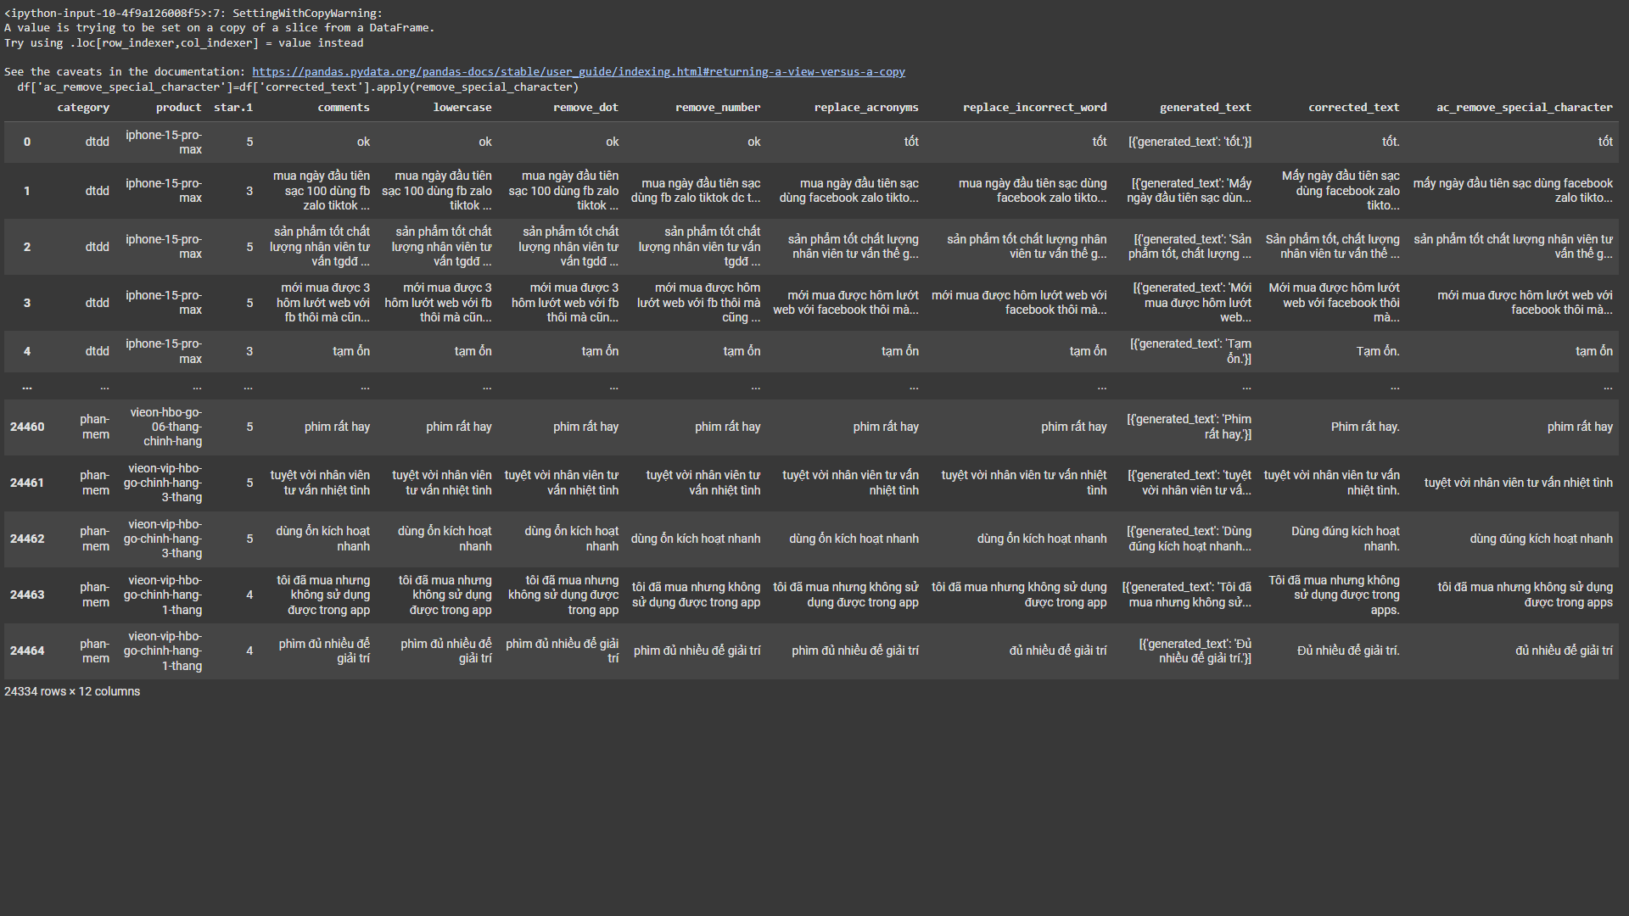

Figure: Loading data in combine_data.csv file

**Step 2**: remove punctuation in sentences

In natural language processing, removing punctuation is a common preprocessing step to simplify data and normalize text. For tasks such as sentiment classification, text classification, information retrieval, or traditional machine learning, punctuation often does not carry much semantic value. Removing them helps reduce the number of words, thereby making the training model faster, limiting overfitting, and improving processing efficiency.

However, removing punctuation also comes with some limitations. In many cases, punctuation carries expressive nuances or helps to distinguish the meaning of the sentence, for example, “bad.” and “good!” have completely opposite emotions. In addition, for tasks that require deep understanding of grammatical structure or context such as machine translation, text generation, or text summarization, punctuation plays an important role and should not be removed.

Therefore, the decision to remove punctuation or not should be based on the specific problem goal. In this topic, Vietnamese sentiment classification using PhoBERT model removing punctuation is reasonable because it helps to simplify the data while still preserving the main semantics of the sentence.

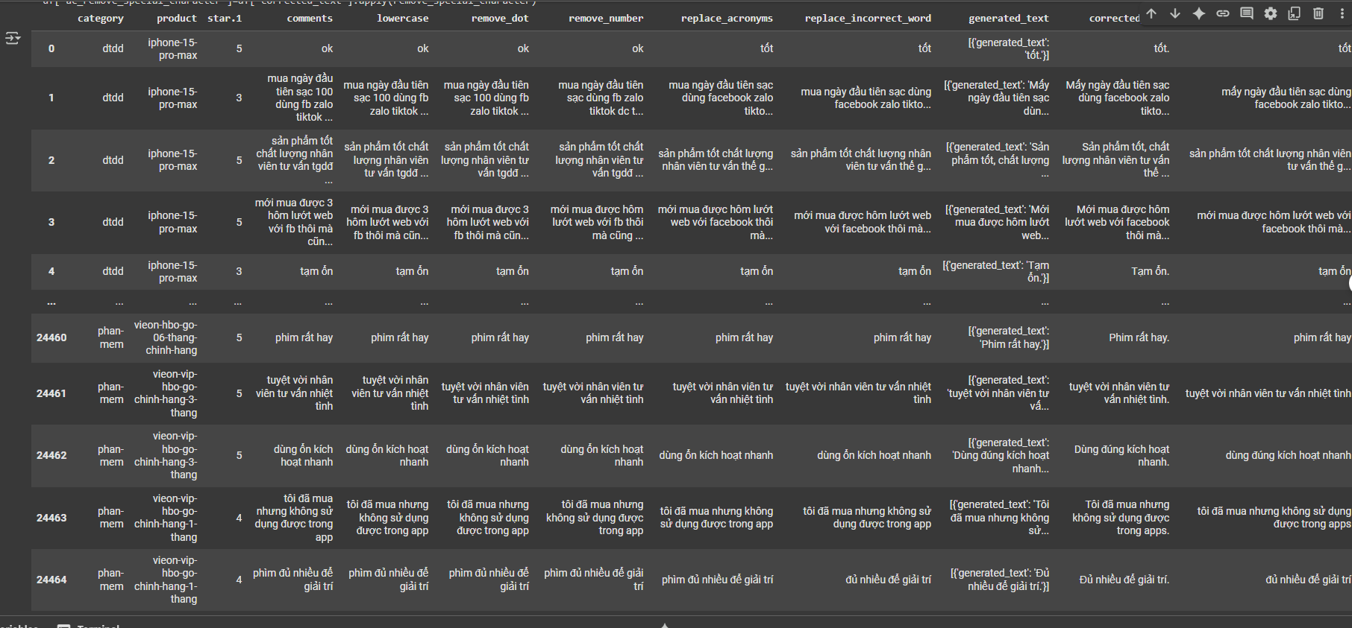

Removing stop words is a common preprocessing step to reduce noise in text and increase the performance of machine learning models. Stopwords are words that appear frequently but do not have much semantic meaning, such as "là", "và", " của" in Vietnamese or "the", "is", "in" in English. By removing these words, the model can focus on more important keywords, helping to improve accuracy in tasks such as sentiment classification or text classification.

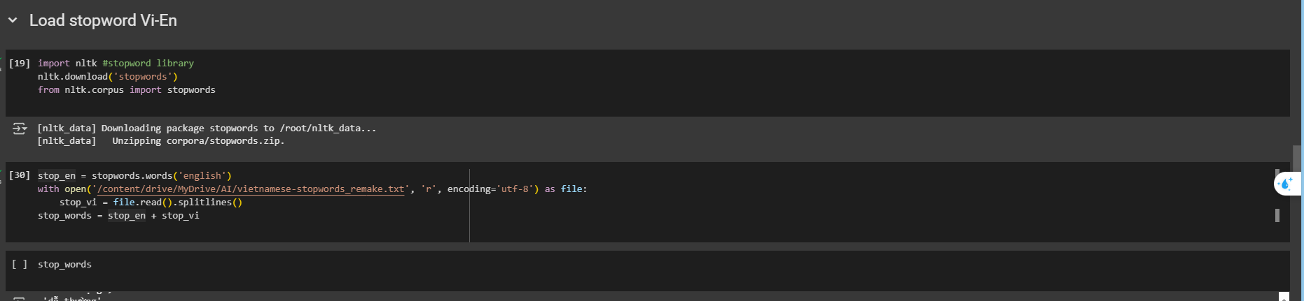

Figure: Installing stopword file txt and filter stopwords in sentence which saved in txt

**Step 3**: Removing stop words in the sentence

In Vietnamese, words are not separated by spaces as clearly as in English, so word segmentation is an important step in natural language processing. In this topic, the VnCoreNLP library is used to perform word segmentation for sentences after removing stop words.

VnCoreNLP is a powerful Vietnamese language processing tool, providing the ability to segment words, assign part-of-speech labels, analyze syntactic dependencies, etc. During processing, each sentence is fed into the rdrsegmenter.tokenize() word segmenter, resulting in a list of semantically separated words. These words are then concatenated into a single string to prepare for the vectorization step or fed into the training model.

Word segmentation helps the model process data better, especially when using PhoBERT a pre-trained language model specifically for Vietnamese and requiring input as word segmented text.

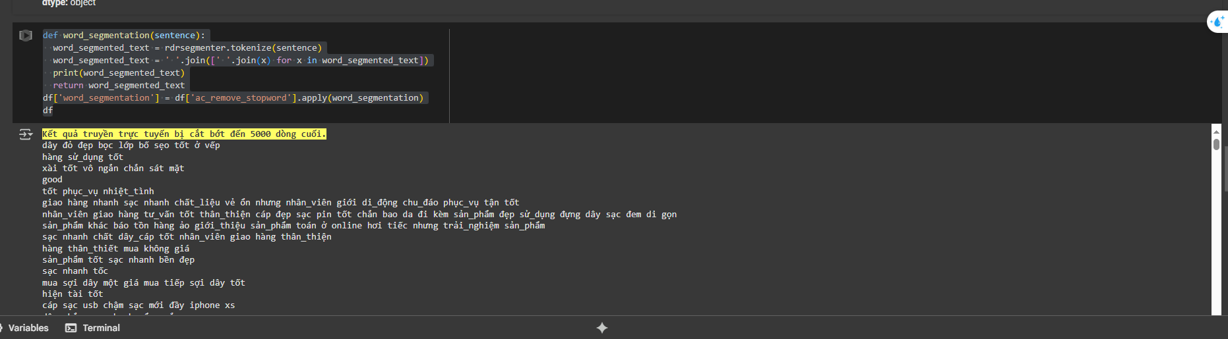

Figure: Standardize sentences by separating words

**Step 4**: space words properly in sentences, then eliminate sentences that are too short or too long

In the process of processing Vietnamese language, word segmentation, corpus normalization and word class identification are important steps to improve the quality of input data for machine learning models. To perform these operations effectively, the team uses the Underthesea library, a powerful Vietnamese natural language processing tool that is easy to integrate in the Python environment.

Specifically, underthesea.word_tokenize() is used to split sentences into meaningful single words, helping to improve the accuracy of text feature extraction. Word segmentation is especially important in Vietnamese where compound words are often separated by spaces, which can easily cause confusion if processed in a pure character style.

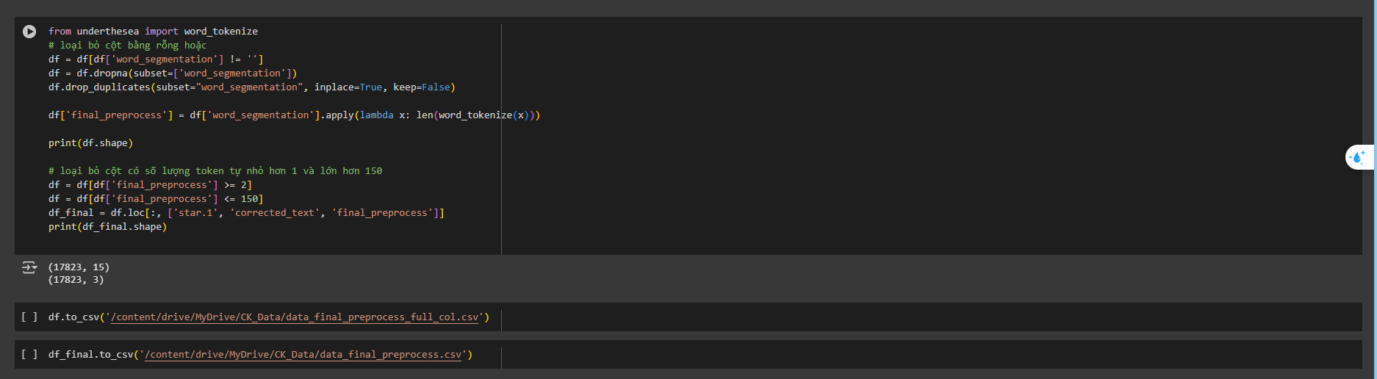

Figure:Filter empty or too long data with underthesea

**2.3 Phobert model of emotion assessment**

This section of the project focuses on the application of the advanced language model, PhoBERT, to solve the sentiment analysis task for Vietnamese-language comments. The primary objective is to build a model capable of distinguishing between Positive and Negative sentiments with high accuracy.

The implementation process includes the following steps:

* Utilizing the pre-trained PhoBERT model.
* **Fine-tuning** the model on the project's preprocessed dataset.
* Evaluating and testing the performance of the fine-tuned model.
* Developing an interactive demo interface using Gradio for result visualization.

2.3.1. **Model Architecture**

To address the binary sentiment classification problem (Positive/Negative), we constructed a neural network architecture built upon the PhoBERT foundation.

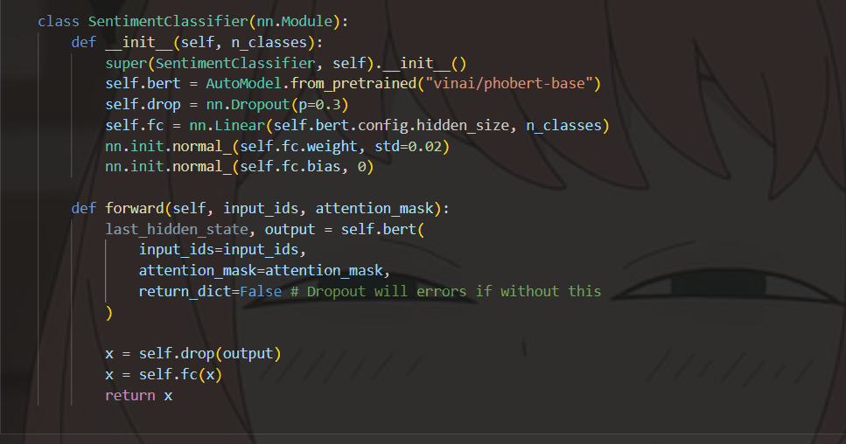

**Flow of Operation:**

1. Input text is tokenized into input_ids and attention_mask.
2. The self.bert layer processes these inputs and extracts semantic features, producing a representative vector (the pooled output).
3. This vector is passed through a Dropout layer, which randomly deactivates some neurons to improve model generalization.
4. Finally, the self.fc layer takes the feature vector and produces the final classification logits for the two classes (Positive/Negative).

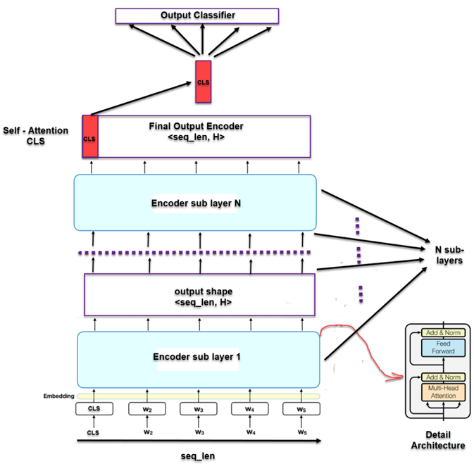

***Figure : BERT base architecture for classification task***

**Key Model Parameters:**

* **Sub-layers (Transformer Blocks):** 12
* **Hidden size:** 768
* **Trainable parameters:** ~110 Million
* **Number of classes:** 2 (Negative, Positive)

**2.3.2. Training Process (Fine-tuning)**

The model was fine-tuned using the preprocessed dataset.

* **Data Split:** The dataset was divided into Training, Validation, and Test sets with a 70% - 10% - 20% ratio, respectively.

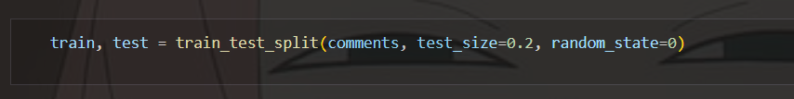

**Explanation:** In the first step, the entire comments dataset is divided.

Test_size=0.2 specifies that 20% of the data will be reserved for the Test set. The remaining 80% is assigned to the train variable.

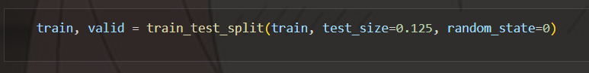

**Explanation:** In the second step, 80% of the data (which is in the train variable) is divided again.

Test_size=0.125 means that 12.5% ​​of this 80% will be used as the Validation set.

We have the calculation: 0.125 * 80% = 10% (compared to the total original data).

The remaining part of the train variable after division will be: 80% - 10% = 70% (compared to the total original data).

* **Hyperparameters:**
  + **Optimizer:** AdamW (optimized for Transformer-based models).
  + **Learning Rate:** 2e-5.
  + **Epochs:** 5.
  + **Batch Size:** 16.

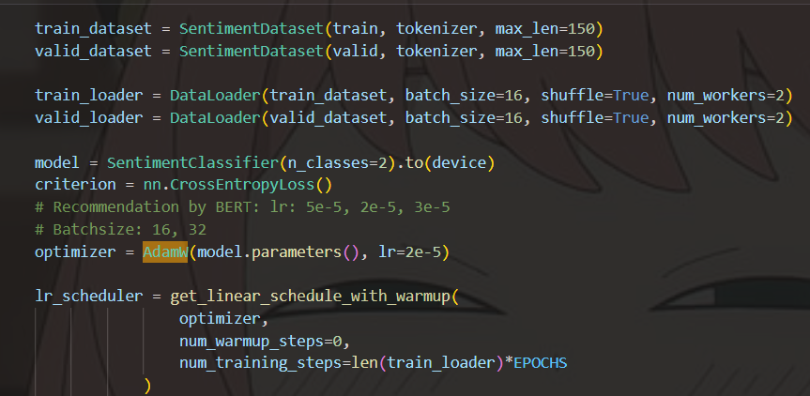

* **Loss Function:** Cross-Entropy Loss, which is suitable for multi-class classification tasks.

The loss function in this experiment is the Cross Entropy loss function with the formula:

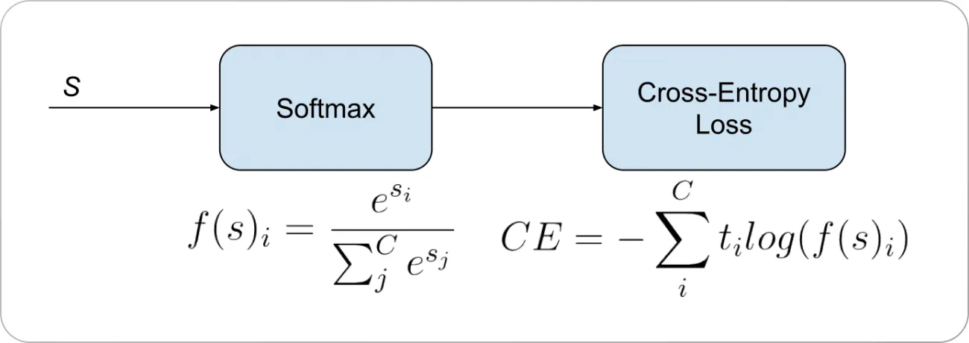

The training process uses the AdamW optimization algorithm, the initial learning-rate is 2e-5, choose from the recommended values ​​from BERT: 5e-5, 2e-5, 3e-5 and batch-size = 16, choose from the recommended values ​​from BERT: 16, 32. The training process is performed over 5 epochs.

* **Model Selection:** After each epoch, the model's performance was evaluated on the validation set. The model that achieved the highest accuracy and F1-score was saved for final evaluation. Based on our experimental results, the model from **epoch 2 (phobert_epoch2.pth)** yielded the best performance with a validation accuracy of **88.99%**.

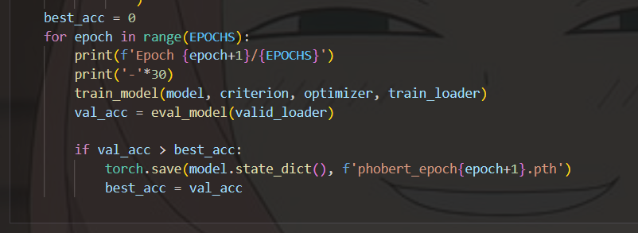

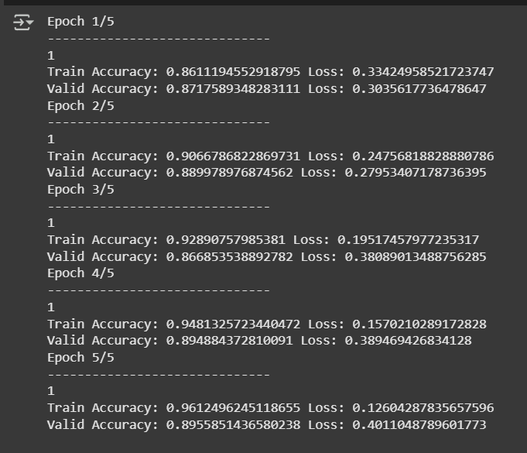

**2.3.3. Model Evaluation and Testing**

This is the most critical step to validate the model's quality. We conducted evaluations using several different methods.

**2.3.3.1. Evaluation on the Test Set**

After selecting the best-performing model (phobert_epoch3.pth), we assessed its final performance on the test set—a dataset the model had never encountered during training or validation.

The results are presented in the Classification Report below:

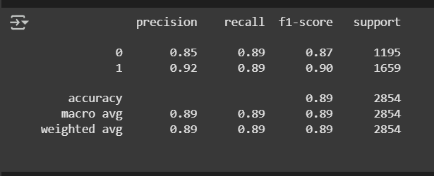

**Result Analysis:**

* **Overall Accuracy: 89%**. This is a very strong result, indicating that the model correctly classifies 89% of the comments in the test set.
* **Precision:**
  + "Negative" class (0): 0.85 - When the model predicts a comment is negative, it is correct 85% of the time.
  + "Positive" class (1): 0.92 - When the model predicts a comment is positive, it is correct 93% of the time.
* **Recall:**
  + "Negative" class (0): 0.89 - The model successfully identified 91% of all actual negative comments.
  + "Positive" class (1): 0.89 - The model successfully identified 88% of all actual positive comments.
* **F1-Score:** As the harmonic mean of Precision and Recall, the F1-scores for both classes are high (0.87 and 0.90), demonstrating that the model is well-balanced and performs effectively on both sentiments.

**2.3.3.2. Consistency Test**

A robust model in evaluation mode (model.eval()) must be **deterministic**—it must always produce the same output for the same input. We verified this by running predictions on the same sentences multiple times.

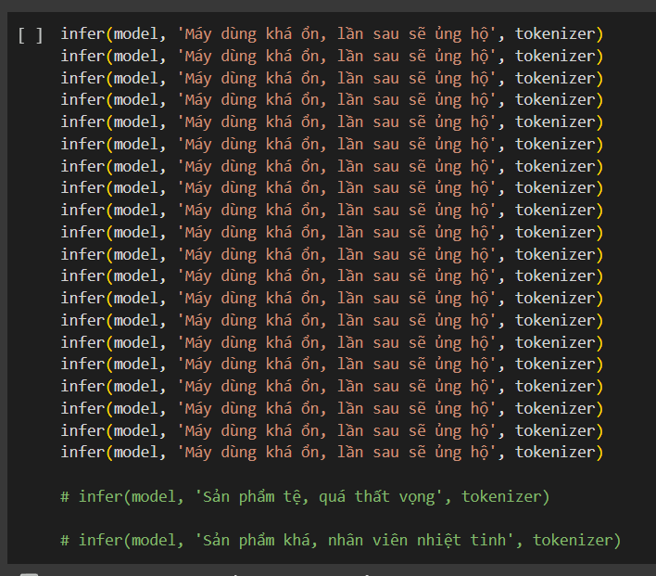

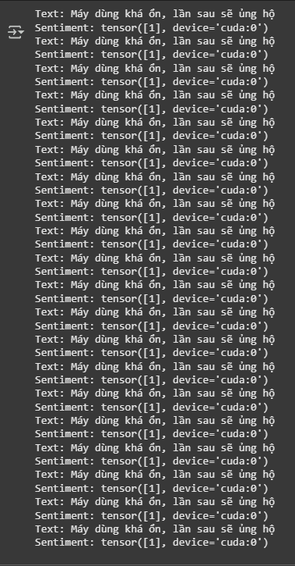

**2.3.3.3. Edge Case Testing**

To assess the model's robustness and ability to handle difficult scenarios, we tested it on sentences with complex structures:

| **Test Case Type** | **Example Sentence** | **Predicted Output** | **Analysis** |
| --- | --- | --- | --- |
| **Short, ambiguous** | "cũng được" (It's okay/fine) | Positive | **Good.** The model correctly interpreted the slightly positive-neutral sentiment. |
| **Complex negation** | "sản phẩm không tệ lắm, nhưng chưa tốt lắm" (The product is not too bad, but not very good either) | Negative | **Good.** The model recognized that the "not very good" clause carried more weight. |
| **Mixed sentiment** | "máy rất đẹp nhưng pin thì quá yếu" (The phone is beautiful, but the battery is too weak) | Negative | **Good.** The model correctly identified the main point of the complaint ("battery is too weak"). |
| **Praise with negative words** | "chất lượng tuyệt vời, không có gì để chê" (Excellent quality, nothing to complain about) | Positive | **Excellent.** The model understood the structure "nothing to complain about" as a strong endorsement. |
| **Criticism with positive words** | "nhân viên rất nhiệt tình nhưng máy thì quá tệ" (The staff was very enthusiastic, but the phone is terrible) | Negative | **Excellent.** The model correctly identified that the object of the review was the "phone" and classified it accurately. |

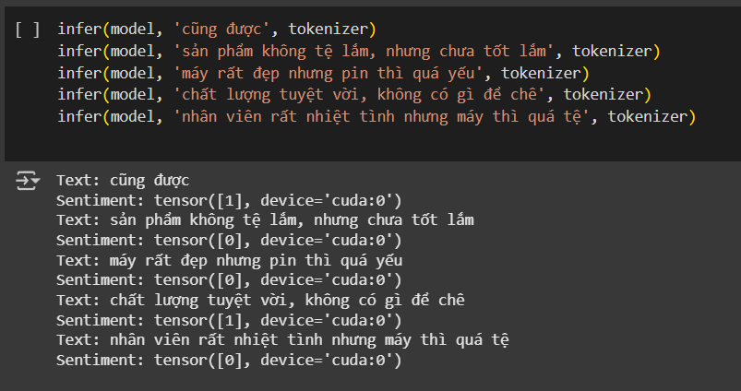

**2.3.3.4. Building a Demo Interface with Gradio**

To make the model interactive and easily testable, we built a simple web interface using the Gradio library.

* **Purpose:** To allow users (e.g., the lecturer, other team members) to input any review and receive an instant sentiment classification without needing to run code.
* **Implementation:** The interface was created with just a few lines of code, directly integrating the predict_sentiment function.

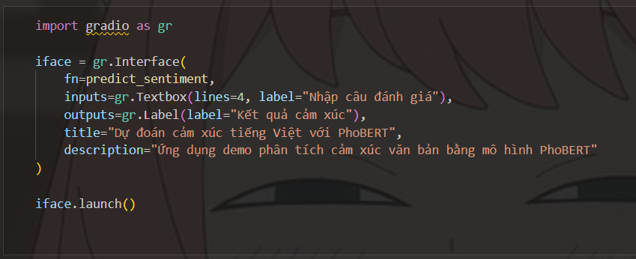

**III. Conclusion and Future Work**

**3.1. Conclusion**

Through the project's lifecycle, from data collection and preprocessing to model building and evaluation, our team has achieved significant results.

1. **Preprocessing Pipeline:** We successfully established a systematic preprocessing pipeline for Vietnamese text, which proved crucial for preparing high-quality data for training.
2. **Model Comparison:** We experimented with and compared traditional architectures (RNN, LSTM, Bi-LSTM) against the Transformer-based PhoBERT. The empirical results clearly showed that PhoBERT (with ~89% accuracy) significantly outperformed the other models, affirming the power of large language models in modern NLP tasks.
3. **Final Model:** The fine-tuned PhoBERT model demonstrated high efficacy and reliability in classifying sentiment, handling even complex cases with competence.
4. **Application Deployment:** A functional demo interface was successfully built using Gradio, showcasing the practical application of the project and allowing for direct user interaction.

While there are limitations, such as the dataset size and coverage of more nuanced language (e.g., irony), the project has successfully met its objectives by building an effective and reliable sentiment classification model.

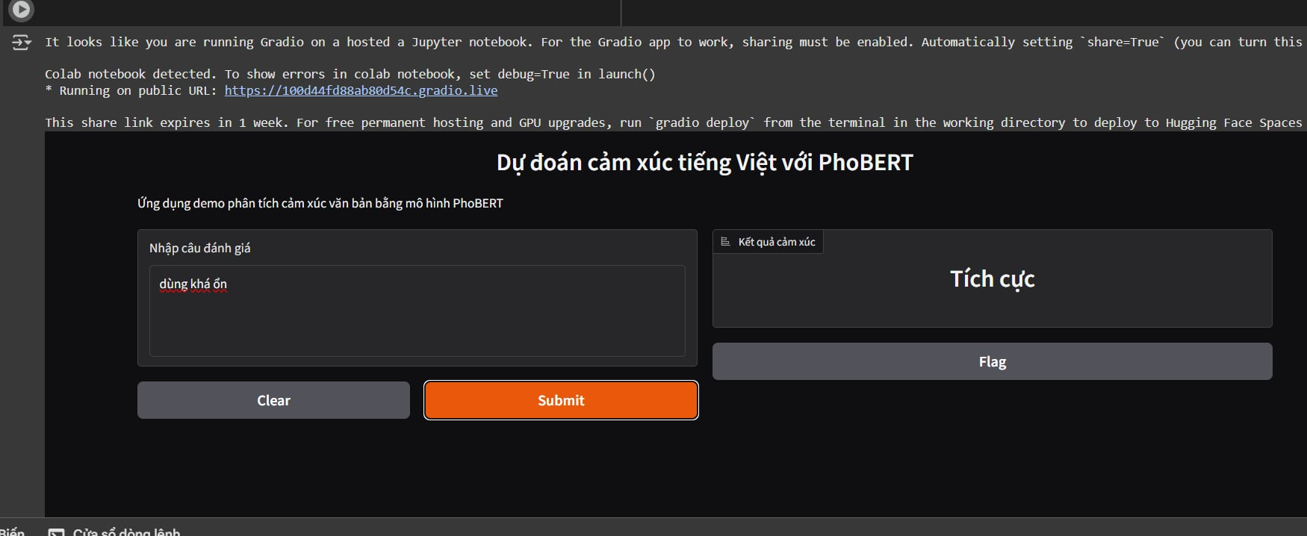

**3.2. Future Work**

To further improve and enhance the model, we propose the following future directions:

1. **Dataset Expansion:** Collect more diverse data from various sources (other e-commerce sites, social media) to expose the model to a wider range of writing styles, especially those containing irony and sarcasm.
2. **Advanced Preprocessing:** Implement techniques to handle synonyms or build a domain-specific dictionary for tech-related terms to further standardize the data.
3. **Hyperparameter Tuning:** Employ methods like Grid Search or Random Search to find the optimal set of hyperparameters (learning rate, batch size, etc.) for the model.
4. **Experiment with Larger Models:** Test and evaluate larger versions of the model, such as phobert-large, to assess potential improvements in accuracy.
5. **Full-fledged Website:** Integrate the trained model into a complete website, providing a tool for users to analyze product reviews, thereby aiding their purchasing decisions.

**IV. Reference**

**[1]** [**arXiv:2006.15994v4 [cs.CL] 25 Sep 2020**](https://arxiv.org/pdf/2006.15994)

[**XLM-RoBERTa**](https://huggingface.co/docs/transformers/model_doc/xlm-roberta)

**[2]** [**vinai/phobert-base · Hugging Face**](https://huggingface.co/vinai/phobert-base)

**[3]** [**[1801.01331] VnCoreNLP: A Vietnamese Natural Language Processing Toolkit**](https://arxiv.org/abs/1801.01331)